**CAN Bus system probing**

Purpose: find UDS-supported CAN ID list

Attack method:

Scan range: 0x600-0x7ff or 0x0-0x7ff?

Service ID range: 0x10 diagnostic session control

Sub-function range: 0x01 default session or more?

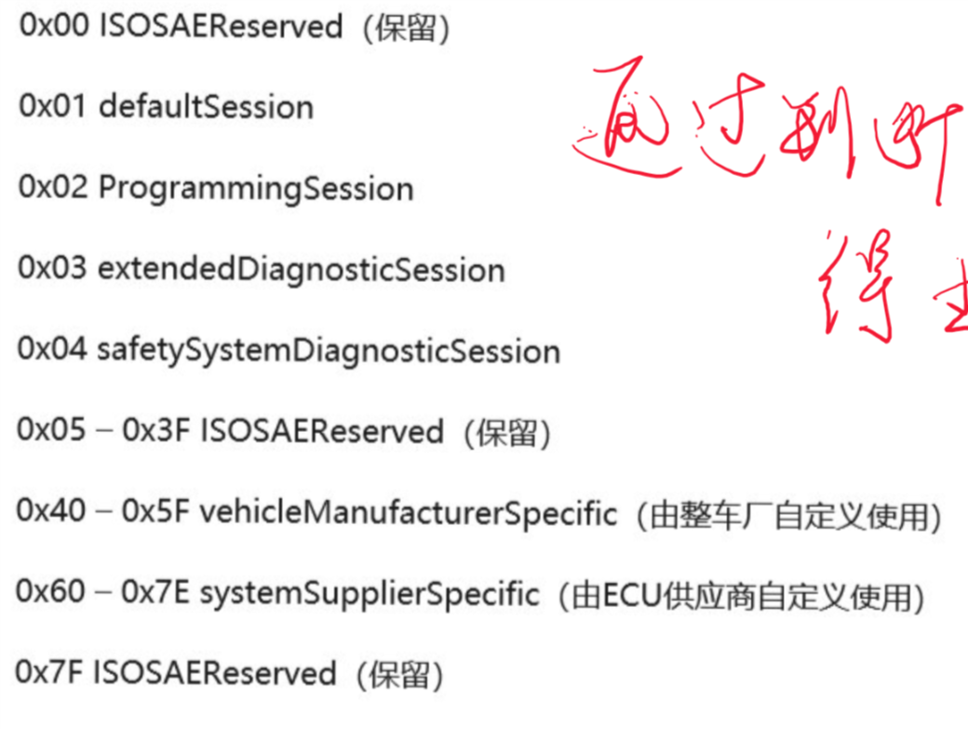

Request message: CAN ID - 0x02 0x10 0x01 * * * *

Response: positive 0X50 and negative response 7F

CAN ID 0x50 0x10 ???

**ECU Service request**

Purpose: find supported service list of the ECU IDs found above.

Attack method:

Service ID scan range: 0x00-0xff

Other bytes: all zeros

Request message: Supported CAN ID - 0x03 0x00 0x0 0x0 0x0 0x0 0x0 0x0

Supported CAN ID - 0x03 0x01 0x0 0x0 0x0 0x0 0x0 0x0

Supported CAN ID - 0x03 0x02 0x0 0x0 0x0 0x0 0x0 0x0

…..

Supported CAN ID - 0x03 0xff 0x0 0x0 0x0 0x0 0x0 0x0

Response: positive = service ID +0x40 and negative response 7F

CAN ID 0x50 0x10 ???